**Praktik Pembuatan Akun Wokwi dan Github**

*Candra Wahyu Perdana*

Fakultas Vokasi , Universitas Brawijaya

Email: candraega28@gmail.com

**Abstract**

This experiment aims to understand the process of creating and configuring accounts on Wokwi and GitHub platforms. Wokwi is utilized as a simulation tool for microcontroller programming, while GitHub serves as a repository for version control and collaboration. The results demonstrate the ease of integration between Wokwi projects and GitHub repositories, enhancing project management and team collaboration. This practice highlights the importance of utilizing these platforms in modern IoT and software development workflows.

*Keywords—Wokwi, GitHub, IoT, version control, collaboration*

**1. Introduction**

**1.1 Background**

Wokwi and GitHub are essential platforms supporting the development and simulation of IoT projects. Wokwi provides a web-based simulation environment for microcontrollers such as Arduino, ESP32, and others. Meanwhile, GitHub is a hosting service for Git-based version control, widely used by developers for project collaboration. Understanding the process of creating accounts on these platforms is a fundamental step for students to engage in IoT development.

**1.2 Objectives**

This experiment aims to introduce students to the process of creating accounts, setting up projects, and managing code using Wokwi and GitHub as a foundational step towards developing more complex IoT systems.

**2. Methodology**

**2.1 Tools & Materials**

* **Microcontroller**: Virtual Arduino Uno (via Wokwi)
* **Software**: Wokwi (https://wokwi.com), GitHub (https://github.com)
* **Internet Access**

**2.2 Implementation Steps**

1. Open the Wokwi and GitHub websites.
2. Register new accounts using an active email address.
3. Create a simple simulation project on Wokwi by adding components such as an LED and a resistor.
4. Save and share the Wokwi project using a public link.
5. Create a new repository on GitHub to store project files.
6. Connect the project files from Wokwi to the GitHub repository via manual download or integration.

**3. Results and Discussion**

**3.1 Experimental Results**

| **Platform** | **Completed Task** | **Key Outcome** |
| --- | --- | --- |
| Wokwi | LED blink simulation | The LED successfully blinks at specified intervals |
| GitHub | Repository with project files | The repository was successfully created and project files uploaded |

Wokwi Screenshot:

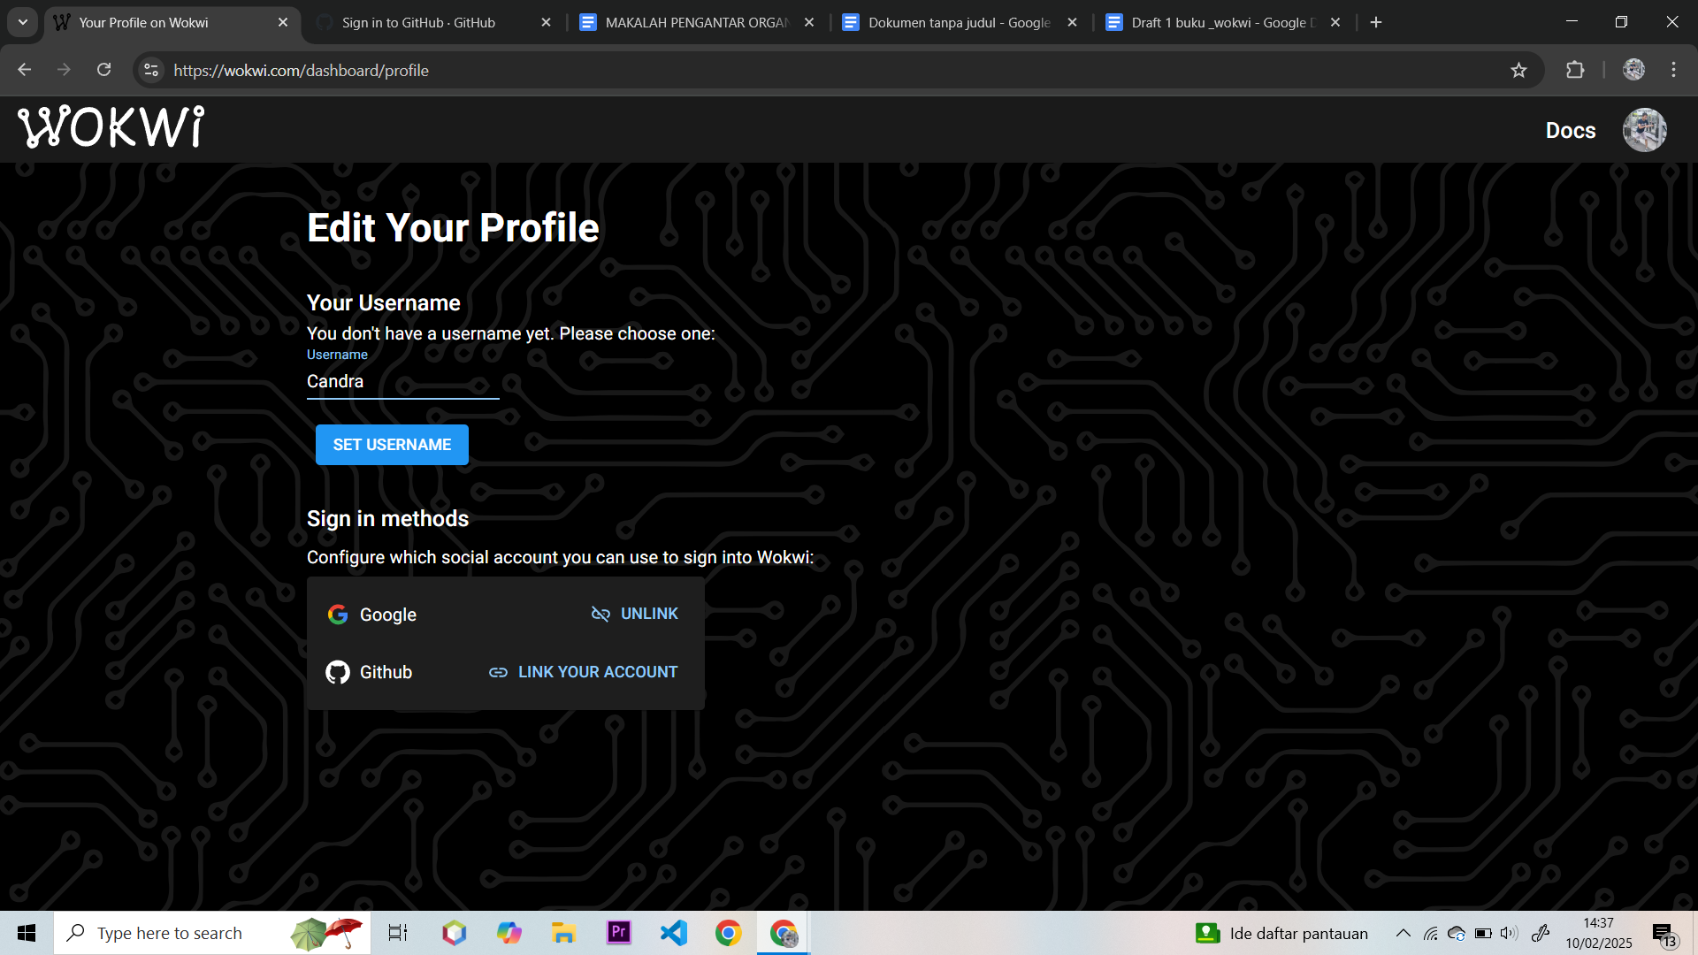

GitHub Screenshot:

